Guide to running Python code in a Simulink model

((For Record version

Part 1: Download model

Link: <https://github.com/ArielMobileLab/Matlab-2020/tree/main/Model_With_Python_Generetor>

Put everything in one folder and in the MATLAB open in the folder:

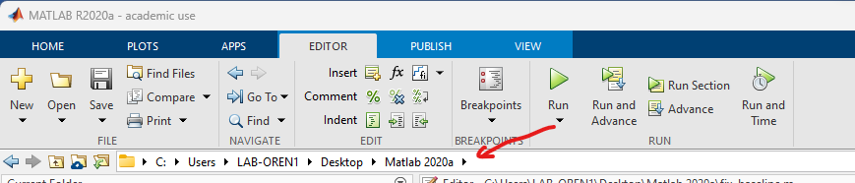

Part 2: Base line

1. Open Amp_baseline_Excel.slx model

2. Open channels data from Excel block

3. in blocks g.tec and tobi put the sheet that you want to use:

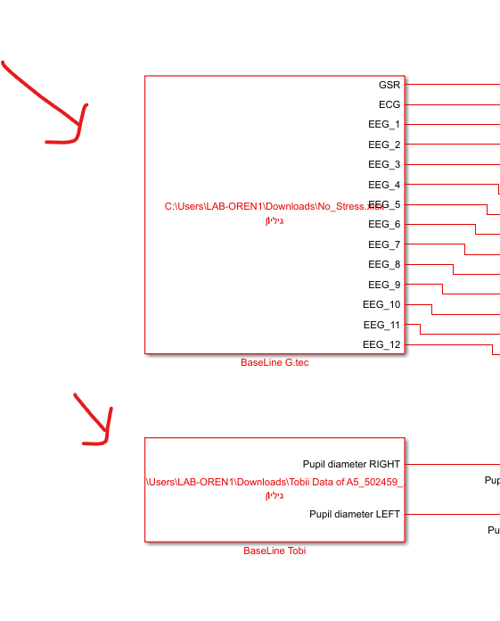

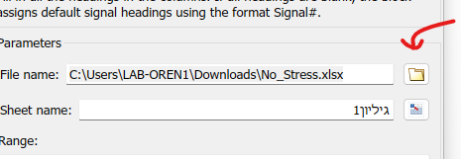

4. Stop time put 60 sec and run the model

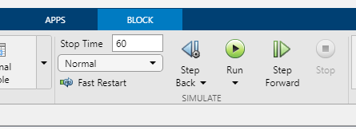

5. Run fix_baseline.m script

6. Open scripts probability_of_mental_load_HR/EYE/GSR/EEG.m, take the Mean and SD from the workspace

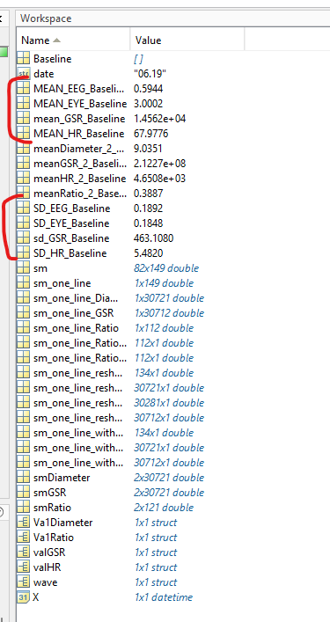

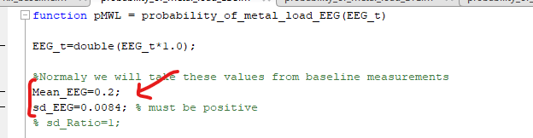Write in the scripts in the Mean and Sd lines

Part 3: Generate python code in the model

1. Open Full_model_python.slx

2. Open channels data from Excel block and put the sheet that you want to us (similar prosses as part 2):

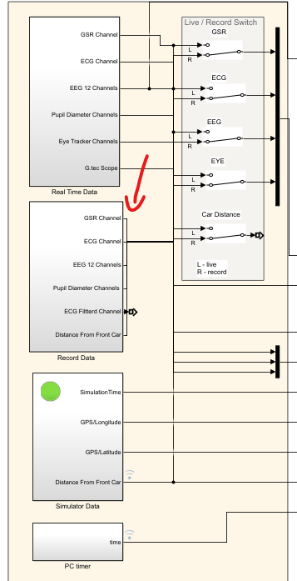

3. Block that responsible for python code generation:

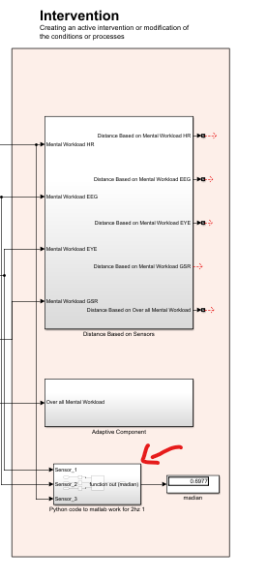

The block have 3 inputs and 1 output.*

* The inputs are connected to work load, You can change this by pulling new lines

* The sample rate of this block is 0.5 sec (2 Hz)

3. To change the body of the python code you need to open Python_Code.py in the Directory:

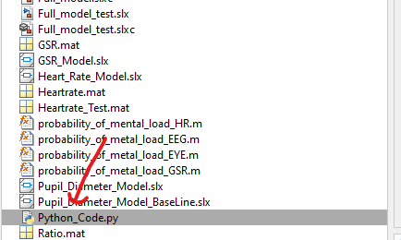



4. run the model in inf time: